ORGANISATION PROFILE 2019

AMICUS INTERNATIONAL

A.I.

Amicus Local NGO

EMAIL: [amicus.ss.org@gmail.com](mailto:amicus.ss.org@gmail.com)

[mdungu17@gmail.com](mailto:mdungu17@gmail.com)

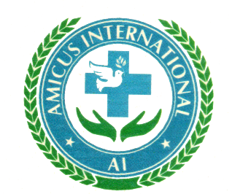

**South Sudan**

The civil wars in South Sudan affected all communities, the most vulnerable population especially women, girls, elderly and children were greatly affected and many found themselves the head of households and the only breadwinners.

The rights of women and children to move freely outside their domestic environment access quality services and education is curtained by reactionary and regressive local traditions, customs and cultural practices;

South Sudan people are displaced on a wide scale by conflicts that engulfed the whole country, citizens not well prepared and communities poorly organized to co-ordinate the activities of various organizations in South Sudan with the view towards working for the advancement of every community in the country.

Disturbed by the fact that some of our local traditions and customs such as forced early marriages, imbalanced opportunities to education and other basic services, which violate the rights of these vulnerable people continue unabated;

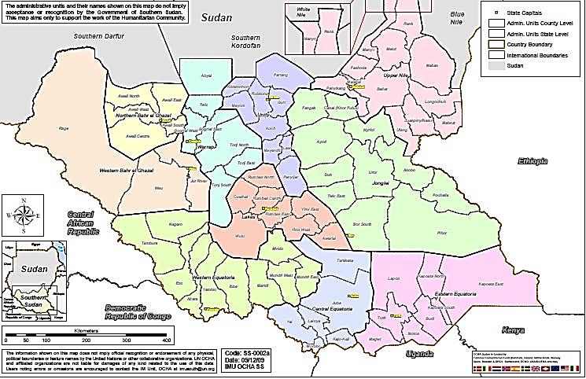Nothing with concern the ever rising incident of conflicts, lack of services to rural communities’ discrimination against women in our society through non-involvement of women in political decision making and their minimal representation in high positions of government and economics power.

Appalled by the dire humanitarian situation of displaced civilians across South Sudan, youth unemployment and the desire to build peace co-existence;

We then formed **AMICUS INTERNATIONAL ORGANIZATION** to address the above concerns through its crafted programs

**INTRODUCTION**

AI is an acronym for Amicus International, which is youth based non-governmental, non-profit humanitarian organization based in Rumbek Western Lakes State – South Sudan it was founded in 2018 following long period of social strife and political instability in South Sudan.

It has a membership of 11, both young men and women the organization has enabled team of young volunteers with a strong popular base.

AMICUS’s activities at first concentrated on two of the most vulnerable segments of the society, the Youths and the street children. The positive impact of this organization is widely felt and is highly appreciated within its own community. AMICUS increased its area of operation and its activities towards the less privileged in its area of engagement.

**The goal of the organization is to facilitate youth-both male and female on an equal basis, beyond clan division in voluntary development activities aimed at improving the quality of life of the community.**

**Vision**

* Our vision is to alleviate stress, poverty and avoidable suffering throughout South Sudan.

**Mission**

**AI, Amicus International was founded on January 27, 2018, to work with the community and advocate on its behalf especially the disadvantaged children and victims of emergencies as well as to participate in rehabilitation programs.**

**Philosophy**

*AI believes that all people deserve equality and should find it an obligation*

*to volunteer in the service to humanity*

**Objectives**

* Support children in difficult circumstance and promote youth employment through trainings
* Advocate gender equity and women empower to articulate their problems and get them solved.
* Promote healthier environment and raise community’s awareness on the HIV and AIDS
* Reinforce good governance which entitles to the voiceless to express their issues.

**Organizational values.**

* Integrity | Inclusiveness | Personal Excellence | Democracy|

| Professionalism |Non-discrimination|

|Team Work & Collective leadership|

Gender Sensitivity |

**Characterizing AMICUS’s Organizational Trajectories**

* AMICUS’s last year’s organizational trajectory can be generally considered as a culmination of its organizational expansion commenced in earlier periods. In the past seven years, AMICUS’s organizational growth has reached its peak in range of areas and aspects. This is more visible in the number and diversity of issues and beneficiaries addressed by AMICUS. The growth is also evident in its current geographical coverage, status and role. Furthermore, this is obvious in AMICUS’s physical growth (size of fund and employees administered). AMICUS undertook and still undergoes structural review to respond and consolidate these multifaceted organizational growths.
* In the period between January and May 2018, Amicus has predominately been working on street children (child rights) issues. It has also been engaged in information provision service. In the early years of this period,
* AI’s operation has mainly been around Rumbek and confined to local level interventions. In addition, it has been primarily focused on service provision activities such as caring and rehabilitating Youths and disadvantaged children. This has expanded as the organization grew both in capacity and finance
* While still continues working on the above issues, AI’s areas of work have been expanded into various fields in the last year1. These includes:
* HIV/AIDS issues (awareness creation, counseling and trainings);
* Water and sanitation issues (accessing water, rehabilitating water infrastructures, setting up and training community water management committees);

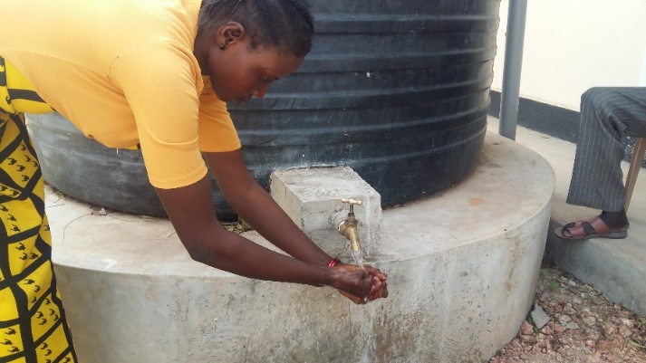

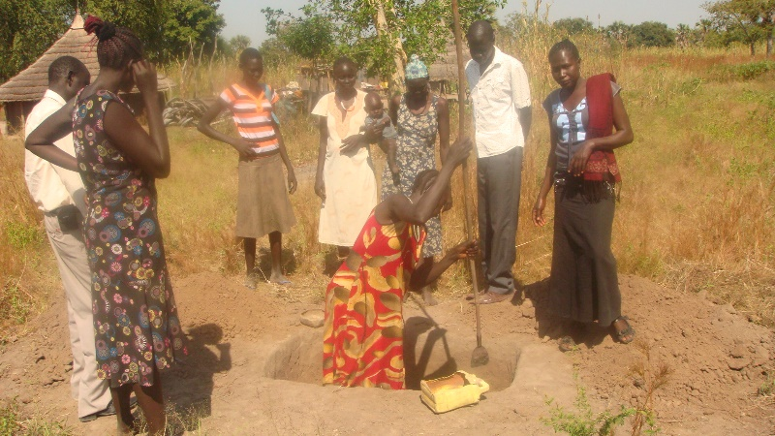

*Teaching the community on construction of locally made VIP to improve on Hygiene*

In the same line, AI’s target groups have expanded from street children, to urban poor, returnees, farming communities, the entire youth community and municipality officials.

* Its local level operations have also expanded to a national level agenda It has started working in various Counties and major towns including Rumbek Wule and Thona-duel, it’s operational

coverage has extended to rural areas.

* AI’s dominantly service delivery role has further broadened into capacity building and community mobilization activities.
* Amicus is playing an intermediary role between citizen and County (local government) and started advocating for community issues.
* In the past years, AMICUS’s status has boosted from a dominantly volunteer and community based local development organization to a recognized and credible national development organization.
* While for the past years AI has maintained its head-office in Rumbek, the organization Is built its new Branch-office in Cueibet Gok State in wider perspective of reaching further beneficiaries new offices are to be opened soon in Wulu County

It’s few and mainly volunteer based services are expanded to various activities largely run by employed staff. AI is now administering close to 15 staffs.

1. In the past year, AI has undertaken governance re-structuring and have developed administrative guidelines (policies) on various issues. Currently, it is also engaged in a more comprehensive constitutional review and policy development endeavor process.
2. This is particularly visible in its water and sanitation projects i.e. through facilitating the formation of community water management committees and providing capacity building trainings for members of the committee.
3. This is particularly true in its market rehabilitation project in Rumbek It facilitated smooth relationship between market vendors and Rumbek authorities. Besides, it convinced the Authorities to shift the market rehabilitation fund from chat vendors to other market vendors.

**AMICUS ORGANISATION RELATIONSHIP**

**CSOs**

**Local Community**

**(Elders Chiefs)**

**Local Authorities**

**Regional Authorities**

**Religious Groups**

AI’s relationships have also showed expansion in some areas in the last year. It has developed new relationships with local authorities (County), external donor agencies and South Sudanese in Diaspora Community. AI further strengthen its existing relationship with religious groups, business community and local communities. But AI still needs to enhance its relationship with local CSOs and the central government’s’ Organizational Capacity

**Conceptual Framework**

***Amicus’s Organizational Emergence***

* 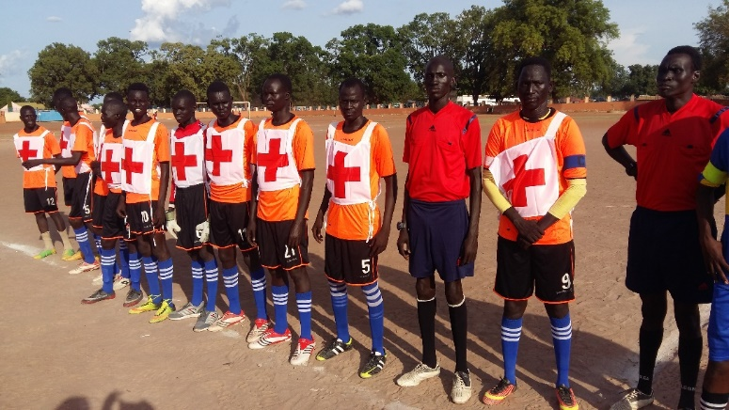**Amicu*s***’s organizational emergence is primarily a response to inter- clan civil strife and the lengthy conflict that utterly shattered and devastated South sudan community in late 90s and early 20s. After the restoration of the peace, some youth in Rumbek town decided to setup an informal forum that will bring together youth from different clan groups. With a view to bridge the social division and avoid similar future clan conflicts, the forum, which latter transformed into ***Amicus***, decided to work together beyond clan division. To bind their commitment, ***Amicus*** Members started voluntary services mainly using local resources.
* The idea of ‘working beyond clan division’ is one of ***Amicus***’s major frames of reference to locate itself within the context. There is no doubt that ***Amicus*** generally perceive clan division as the main source of conflict and major development obstacle in South Sudan context. But, ***Amicus*** needs to elaborate further its understanding of how clan division contributed and will contribute to conflicts in South Sudan. There is a general tendency to link the idea of clan, tribe or ethnicity with conflict and destruction. Due to this usually there is an inclination to deny their existence and regard them as obstacles to any peace building, democratization and development process.
* The post-conflict South Sudan coincided with enormous challenges of coping with trauma, reconstruction, HIV/Aids, poverty, unemployment among many other social challenges. The hunger to fill this gap by either the locals or international community in providing assistance brought into existence.

***Major Areas of work***

* At first, AMICUS’s major area of work has been around Street Children. Its justification was that due to the long conflict there are significant number of people experiencing war trauma who needs due attention. AMICUS’s argument and activities around ‘war trauma’ is relevant in post conflict situation. This was evidenced by the increase in the number of mentally ill people who either sought medical attention in ill-or unavailable mental health services or found their ways on the streets. What captured the attention of AMICUS was the neglect of this group of people.
* In addition to mental health issues, AMICUS has also been engaged in various fields. Unlike normal situations, development needs different approaches in the post conflict and highly vulnerable circumstance. Under such difficult context there is huge demand on development organizations to fill the gaps left by the destruction of the social fabric and the state infrastructure. There is an immense demand and expectation to provide services to ensure the survival of the community and resources to support reconstruction efforts.

AMICUS’s involvement on various issues in services provision and rehabilitation efforts may be justified on this ground.

* In line with above statement, AMICUS felt the desired social fabrics to be reconstructed in post conflict South Sudan as HIV/AIDs interventions, education, good-governance and democracy and poverty reduction. AMICUS thought and still thinks as these as major impediments to South Sudan’s reconstruction. The organization muscles both human and financial resource in dealing with these crises through community based initiatives.

***Community development approach***

* 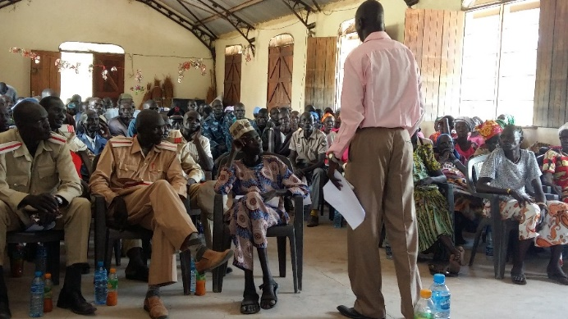AMICUS’s community development approach is based on various implicit and explicit frames of references. AMICUS '’s philosophy which is the, ***believes that all people deserve equality and should find it an obligation to volunteer in the service to humanity***” developed a detailed policy on volunteerism. According to the policy, AMICUS encourages and accepts the involvement of volunteers because it believes that the “***achievement of its goals are best served through the active participation of the community***. The policy implicitly promotes one of the conceptual frameworks of AMICUS’s community development approach i.e. active community participation.
* In addition, community ownership and self-reliance are other implicit conceptual frameworks of AMICUS’s community development approach. AMICUS promotes this partially through its local fundraising program. Like volunteerism, it developed local fundraising policy. According to this policy, the purpose of the local fundraising is to provide ways for the community to help themselves without waiting external resources. The policy further stated that in addition to covering the needs of vulnerable groups, the local fundraising also strengthens the relationship between the community, AMICUS and partner organizations. Community consultations and respect for their views are another strategy adopted by AMICUS to promote community ownership.
* Addressing the real needs of the community and working with authorities are some of the recent additions that inform AMICUS’s community development approach. Similarly, AMICUS has started playing an intermediary role between citizens and community. Besides, lately it has been engaged in capacity building activities and in community advocacy role.
* **AMICUS** has been actively involving religious groups, clan leaders and elders in its activities. In light of the existing strong traditional institutions and weak government structures in South Sudan, involving such groups is inescapable to materialize any development initiatives. AMICUS is attentive that there is still needs to develop and make explicit its social transformation approach under such context. AMICUS also is conscious that such strong traditional institutions may be an obstacle to social transformations which may also perpetuate the underdevelopment or exploitation of some segments of the society particularly women and children.

**B) ORGANIZATIONAL CULTURE**

***The invisible aspect “Attitude”***

* 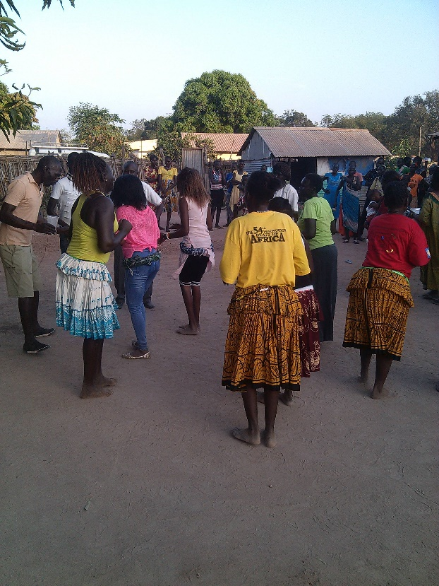AMICUS’ members demonstrated a high level of confidence and responsibility in their activities. Their confidence is specially displayed in their decision to work on or address the inter-clan conflict that distress South Sudan community. Their attempt to bring together youth from different clan groups and to work beyond clan division exhibits a high level of self-confidence. In addition, AMICUS decision to use local resource and promotes self-reliance is another prove of its confidence.
* AMICUS members did not complain and deterred by the extremely difficult South Sudan context when they decided to address the situation. They take initiative to change the situation through their own effort. This shows high level responsibility on the part of AMICUS members and other respected staff. This is also demonstrated in their decision to concentrate in their activities on the most vulnerable segments of the society, the mentally handicapped and the street children.
* While AMICUS demonstrated some positive attitude towards gender, it has come long way in addressing and integrating gender issue both at organizational level and within its project activities.

***c) Vision and Mission; Purpose and Will***

* AMICUS stated that its goal is “to facilitate youth-both male and female on an equal basis, beyond clan division in voluntary development activities aimed at improving the quality of life of the community.” It further indicated that the organizations vision is “to alleviate stress, poverty and avoidable suffering throughout the South Sudan.” Besides, it stated that its “mission is to work with the community and advocate on its behalf especially the disadvantaged children and victims of emergencies as well as to participate in rehabilitation programs”
* It seems that AMICUS developed a clearly articulated organizational goal, vision and mission. But it is very difficult to say that AMICUS’ has clarity of focus and coherence regarding its organizational direction. AMICUS’s organizational intentions seem to infer two parallel trends.

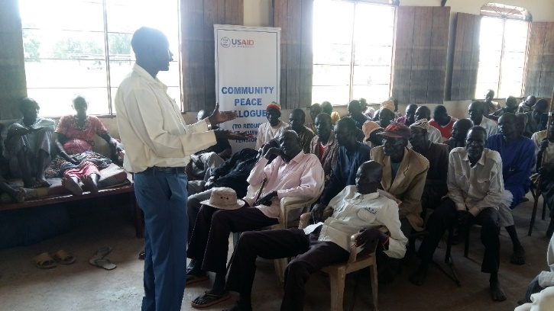

***First a volunteer based organization that promotes inter-clan youth participation. Second a development organization focusing on vulnerable groups and rehabilitation works. While the first*** focuses ***on promoting community participation for peace building and addressing inter-clan division, the latter mainly focus on development activities.***

* AMICUS, seems to indicate both focus areas. According to AMICUS’s volunteer policy, it encourages and accepts volunteers because it believes that the achievements of its goals are best served through the active participation of the community? According to this policy, the organization recruits volunteer on pro-active base with the intention of broadening and expanding volunteer community participation. The policy further stated that volunteers are recruited through either an interest in specific functions or through a general interest in volunteering which will later be matched with a specific function. It

appears from these that the purpose of AMICUS’s volunteer policy supports the first direction of the organization i.e. a volunteer organization that promotes inter-clan youth participation.

***d)* Organizational strategy**

AMICUS had developed a comprehensive and integrated organizational strategy. Its first year’s strategy commenced from 2018 and ending 2019 have been developed which ranging a various prioritized areas of intervention with set of the following identified approaches.

**Active community participation approach**

• Enhancing volunteerism

• Creation of community’s ownership and self-reliance (local fund raising)

• Advocacy and lobbying

**Community development approach**

• Alleviate the community vulnerability by helping socially and economically to help themselves

**Organizational development approach**

• Enhance organizational Field of expertise

• Preserve Organizational Values and its reflections at all levels Apart from the above mentioned approaches AMICUS has articulated and clarified its strategic

areas as under listed;

* ***Health***_ ***Education***_ ***Capacity building***
* ***Women and youth development***
* ***Good governance***

**E) SYSTEMS AND STRUCTURES**

Previously, AMICUS had a Chairman and an Executive Committee governance structures.

Members of the committee were also responsible for implementing its activities. This created confusion particularly in relation to accountability. In order to address this issue and to continue engage its previous members, AMICUS created a Board and Executive Director structures. Founding members including those who left AMICUS become board members started overseeing AMICUS’s overall policies. The Executive Director becomes responsible for running the day-to-day activities of AMICUS. AMICUS adopted the following governance and administrative structures in March, 2005.

**MEET THE TEAM**

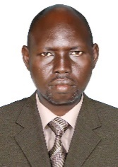**Mr. Marco Marijan Dungu**

**Director/Founder of Amicus**

Current Principle Rumbek University of Science & Technology



**Mr. John Frances Olacho**

Executive Director Amicus Inter

And Project Manager Amicus Construction Company

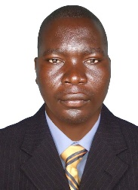

**Mr Okello Denis Oyugi**

Finance & Operations

Amicus Inter

Engineer/ trainee for Amicus

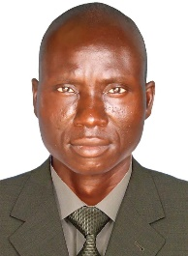

**Mr Bosco Okoth Penywii**

Programs Officer Amicus international

Trainee & Youth Mobiliser

**ORGANISATION STRUCTURE**

GENERAL ASSEMBLY

BOARD OF DIRECTORS

EXECUTIVE DIRECTOR

ADMIN/

FINANCE

PROGRAM OFFICER

***General assembly***

* The general assembly is found at the top of AMICUS’s governance structure. But, still AMICUS did not have a designated body constituting the general assembly. AMICUS consider the community in general as its general assembly. Since, AMICUS is in the process of redefining its governing structure; the general assembly is expected to be formed in the future. But, AMICUS has been using various mechanisms, such as advisory committees, to consult and collect feedbacks from members of the community.

***Board of directors***

* At present the board of directors is the highest decision making body in AMICUS’s administrative structure. It is composed of seven members, three are found outside AMICUS, whereas the remaining four are working (as full time employee) within AMICUS. The board set the overall direction of AMICUS and decided on policy and strategic issues. The board also checks whether new projects are in line with AMICUS’s values. Even though the numbers of AMICUS’s founding members are decreasing from time to time, the remaining members are very cautious about recruiting new board members. It is indicated that board members are still committed to AMICUS’s, spirit, vision and goals; and the latter are serving as a strong binding factors for members.

***Management***

* AMICUS’s day-to-day activities are administered by a full time Executive Director. He is supported by project/program managers. AMICUS classified its various projects in to five major program areas. These are Health Program (metal health and HIV/AIDS projects), Education Program (projects for children in difficult circumstance on basic education and skill trainings, and youth

multipurpose center project), Water and Sanitation Program (water management projects, solid waste management projects, Rumbek market rehabilitation projects), Rural Development Program (farming community water infrastructure rehabilitation Project and agricultural water improvements project) and Cross Cutting Programs (Land management house-to-house survey, FGM and strengthening

Democracy and Good Governance projects).

***Monitoring and evaluation***

* AMICUS uses various mechanisms to monitor its projects. Monitoring, evaluation and learning handbook is developed and applied to cope all M & E and learning practices. Project managers conduct daily and weekly monitoring. They also submit monthly progress reports to the executive director. Both qualitative and quantitative data are collected in the reports. Various formats are developed to facilitate the monitoring process. In addition, site visits are conducted by the Executive Director and Board members.

***Financial System***

* AMICUS has adopted detailed administrative and financial systems in 2018/2019. The administrative manual contains personnel and financial polices and procedures. The financial manual includes a comprehensives financial, fixed asset, procurement and inventory policies. AMICUS has an administrative and financial officer responsible for handling administrative and financial issues. AMICUS keeps checks and two-bank accounts in **ECO BANK JUBA** and **CO-OPERATIVE BANK** which performs as bank/facilitator in South Sudan. Project funds are released on quarterly basis. Financial reports are made within the same period, but there are also some monthly financial reports. AMICUS also recruits its own independent internal auditor when and where is required.

***f) Skills and abilities***

Board members have different qualifications which are applicable and are attentive to their role and responsibility in the body as Board members. The Board members have also clear job descriptions.

Board members indicated that they are facing capacity or skill gaps that parallel the organizational growth of AMICUS. They specifically indicate that they need project management skills particularly around need assessment, monitoring, evaluation and research skills. They also indicated that they need capacity building around advocacy and policy formulation skills. At institutional level AMICUS is developing change facilitation, negotiation and capacity building skills. They are also enhancing their expertise around various issues including mental health, water and sanitation, HIV/AIDS and promotion job opportunities through vocational skills trainings.

**AMICUS’s Skills Indicators**

Change facilitation, negotiation and capacity building skills

The capability to act as an intermediary between those affected (market vendors) and those responsible for planning and implementing the change i.e. rehabilitation of the market. Successful application of negotiation skills in holding together and resolving tension:

***g) Human and Material resources***

***Human Resources***

• Currently, AMICUS is administering more than 53 staff. A large number of them are paid staff, while others are volunteers. 30 out of 53 staff is professional and competent to their roles. The bulk of AMICUS’s staffs are found in its HIV/AIDs-Projects and education/youth projects. Among these social workers and skilled teachers comprise the highest number.

***Material Resources***

• AMICUS has two offices in Rumbek, and Cueibet. a multipurpose youth center and psychosocial center in Rumbek. It has also one vocational training center in Rumbek under Save the Children. Both offices are equipped with essential office furniture and have access to Internet, fixed line and mobile phones.

**d) Support children and Youth**

AMICUS has been supporting children in difficult circumstance through provision of basic

alternative education, skills training and feeding since 1997. In the last three years, AMICUS

has expanded its vocational training centers to receive more children and diversify.

**Vocational and Skills training:** AMICUS in collaboration with Save the Children and TVET Programe established Center for children in difficult circumstance (vocational skill training and alternative basic education) for vulnerable children early in the year of 2001.

The aim of the program was to reduce the number of children in the streets drastically and educate illiterate young women, and ensure sustainability of the program to alleviate the living conditions by equipping them with skills and alternative basic education. A fundamental stride has been made for the last two years. (See AMICUS’s program achievements)

The center is currently implementing the following vocational training skills: -

* Electricity
* Brick laying and Block Molding
* Carpentry
* Plumbing
* Computer
* Basic fishing
* 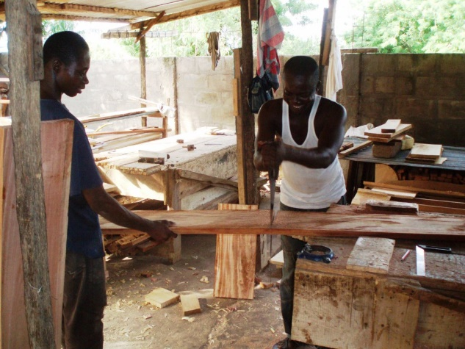Solar energy

*Youths at the carpentry workshop acquiring skills*

**Establishment of Youth multi-purpose development centers:** YMDC (youth multi-purposedevelopment center) approach that was initiated byAMICUS in collaboration with and **VISTAS** which established its firstyouth multi-purpose development center at the heartof Rumbek city is a participatory bottom up, capacity oriented process that positions information resourcecenter as building block for youth development movement. The methodology focuses on the buildingyouth and community information resources that matter to the youth people and on the creation and nurturing of community structures around it by aligning information and recreational services, reading, learning and playing with development the approach aims to:

* Increase the use of new information and knowledge to help youth to manage changes, to improve their skills and thinking and to learn better health practices to protect themselves and their families
* Bring out the capacities of the youth community, and their deep and rich knowledge that was marginalized by chat chewing, clan divisions and other discouragements.
* Limit idleness and redundancy that will otherwise involve the youth to path of destruction ie the participation of inter-ethnic war, drug and other substance abuse among others and instead focus their conscious on been resourceful in to the themselves, their country and humanity

**Adult education**

AMICUS is planning on offering adult education for 30 illiterate young women in RUMBEK which will last for a year due to financial challenges most of the graduated women will be able to read and right and out of the few will be enrolled to computer and beauty therapy in vocational training center. In addition to that, AMICUS has initiated a Youth education pack (YEP) through the formation of youth education centers aimed to support and empower youth and destitute children those belonged to IDPS and returnee’s in AMICUS Organizational Profile Helping People to help themselves

**Child protection in police forces**

AMICUS has been very active taking a tremendous role in working and supporting child rights protection at all levels in the local community through various means. AMICUS has organized consultation and awareness workshop on child rights and as well training workshops and other events on child rights protection. In recent years, AMICUS has successfully achieved the promotion of effective child rights protection in police station. Establishment of child protection units in Rumbek police station by Save The Children, training sessions for educating police, provision of office equipment and capacity support are among other methods those have been used in child rights protection

**Body of social learning**

AMICUS and VISTAS have been working together since 2018, South Sudan become one of the countries in the Horn of Africa in which PACE program will be implemented. AMICUS in collaboration with Western Lakes Counties and other stakeholders with funding support from VISTAS will implement and entitled to carry out the PACE project in South Sudan.

**Purpose:**

* *To increase intersectoral relationship capabilities of civil society, state structures and*

*business to interact and work together.*

**Objectives:**

* *Promoting participatory local governance*
* *To advocate for enactment of mental health policy*
* *To train and adopt participatory local governance*
* *To network with other partners who are implementing the project in the region*

The PACE project in South Sudan will be mainly focused and executed in two regions of Rumbek (Eastern region) and (South region) with the intervention of the following areas;

* Organize and conduct training workshop on policy formulation.

1. **Advocating for a change.**

* Sensitization activities around policy, lobbing and advocation the development of the

policy.

1. **Capacity building in participatory local governance.**

* Organize and conduct training workshop on local participatory Governance.
* Innovative exposure visits.

1. **Regional networking among program specific beneficiaries**

* Through exposure visits

1. **Promotion of links between communities and local County for better services**

**delivery to the community and active community participation.**

* Small grant projects

**f) Local fundraising:**

As AMICUS believes, the richest resource of a community is not the money raised from donor agencies. The most important resource is the will of the people for sustaining their socio-economical activities. One of the key elements in achieving sustainability is participation of the local community in the full range of all activities.

The local resources mobilization which is under AMICUS’s active community participation approach is designed to strengthen the ability to facilitate a continuously improving virtuous cycle of

*women conferences’on children rights and HIV Aids Control*

active citizenship

The importance of creating effective management systems for local resource mobilization for AMICUS’s current projects and its future sustainability and the ideas “to help poor people to help themselves is the driving force to fundraise locally to assist the vulnerable member’s in the community. AMICUS establishes project management committees to involve local community in participation in project planning, designing and implementation.

**Scope of the program**

* Building general awareness and knowledge, especially among vulnerable groups to ensure they are well aware of the basic facts on HIV/ AIDS such as what it is, how it spreads, prevention measures etc.
* Advocating for expanded involvement in HIV/AIDS prevention and care by all sectors of society through involving groups as well as individuals. Such

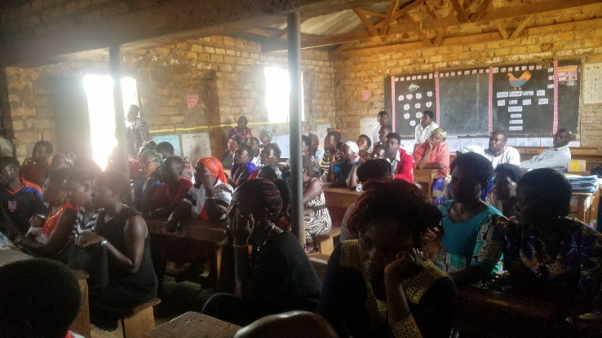groups include; other local NGOs, CBOs, youth groups, religious leaders and students. Such groups have closer links with the local community and can have influence on issues surrounding them. Therefore, by educating and encouraging them to participate in HIV awareness raising campaigns and strengthening solidarity will have greater impact in the community as whole. Also the formation of groups that will encourage open discussions on the prevention of the disease will be the most important activity

**HIV & AIDS program**

AMICUS is one of the active organizations that are taking leading role in the advocating for better and realistic approaches to deal with pandemic in order to break the grip of HIV/AIDS in South Sudan. Currently AMICUS with its respected partners under takes culturally reintegrated approach to reach the local community and especially the youth that are more prone to disease. An initiative those will provide information, knowledge and skills on prevention HIV/Aids will be the essential larger population and specifically to residents

* Encouraging the use culturally and socially acceptable methods of preventing the spread of HIV. It will encourage healthy behaviors and advocate for change of risky behaviors which lead to spread of the disease. Abstinence and faithfulness, which are both culturally and religiously acceptable, will be the main message that will be passed to the community. High risk groups as well as individuals particularly the youth will be made aware on how to take personal responsibilities for preventing HIV infection.

**OUR YOUTH ENGAGEMENT**

**PROGRAMMES**

**Civic participation:**

We train young people to understand and engage with government structures at local and national level. We support young people to track service availability in their communities and report their findings to decision makers.

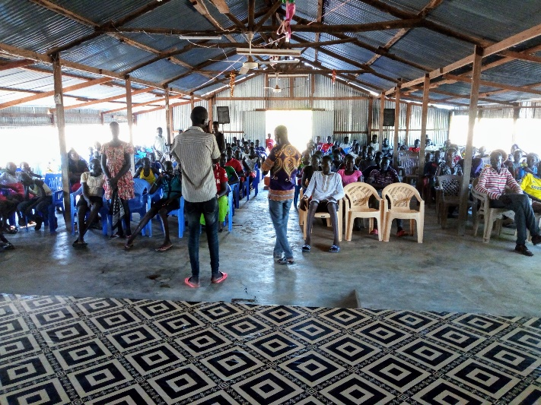We organise forums through which young people can have a voice in key national and international debates – for example we organized consultations on the National Development Plans, facilitated a Ground Level Panel to gather views from South Sudanese most disadvantaged communities on the Sustainable Development Goals, and organised young people to feedback to decision-makers to inform revisions to the National Youth Venture Capital Fund.

*Youth sensitization*

**Livelihoods:**

Our livelihoods and employment programmes support young people to pursue one of two pathways; self-employment or employment. Amics Development uses a step-by-step approach to supporting youth to build and grow market-driven enterprises. We identify existing, or establish new,

youth groups and support them to register and develop strong governance structures. We provide training in core life-skills (e.g. leadership, teamwork, and effective communication) and enterprise development (e.g. business planning, networking, and marketing) to the youth groups on a weekly basis through our network of peer educators based in the community. Training is

co-delivered with government and local entrepreneurs. As part of their training, we support the youth groups to undertake a rapid market

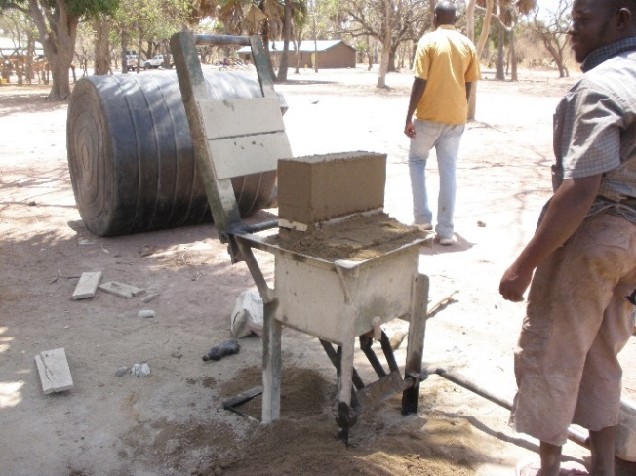assessment and draw on this to identify a market-driven enterprise.

We then link the groups to relevant stakeholders to access technical training and mentoring support tailored to their particular enterprise. For example,

for agricultural enterprises this could include linking youth for advisory services. We support

all groups to access the financial support required by providing training in financial literacy, supporting them to establish savings groups, and

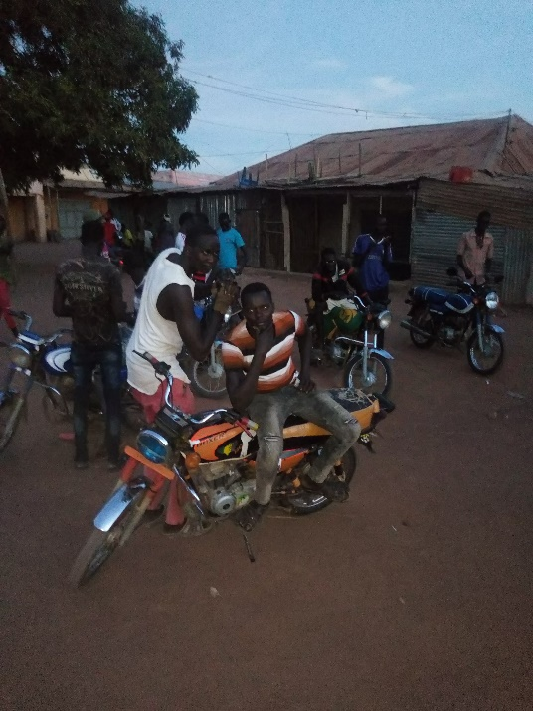connecting them to financial institutions such as Savings and Credit as well as local government funds.

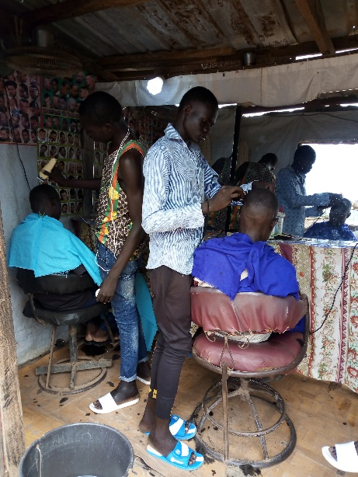

*Wealth Creation by Youths*

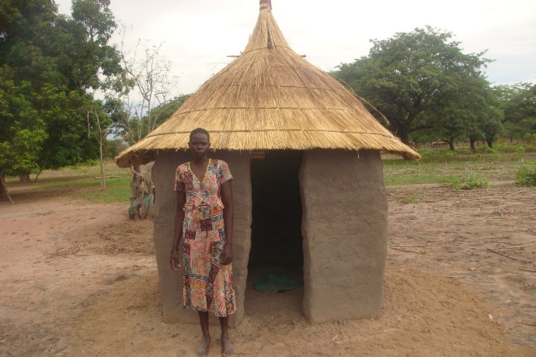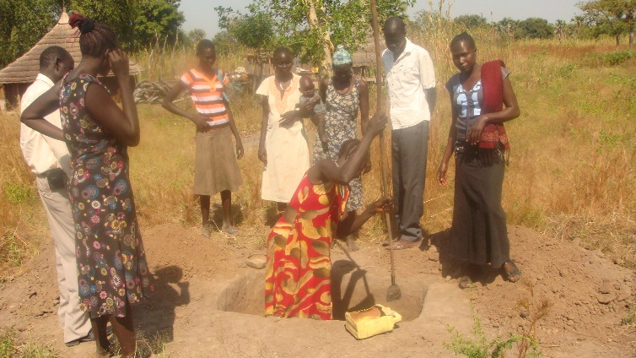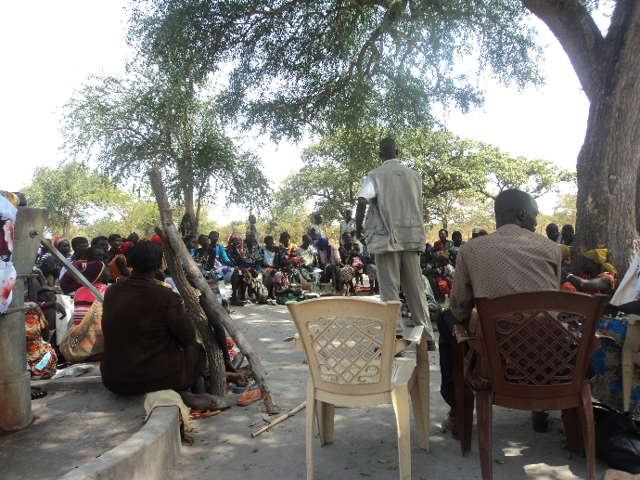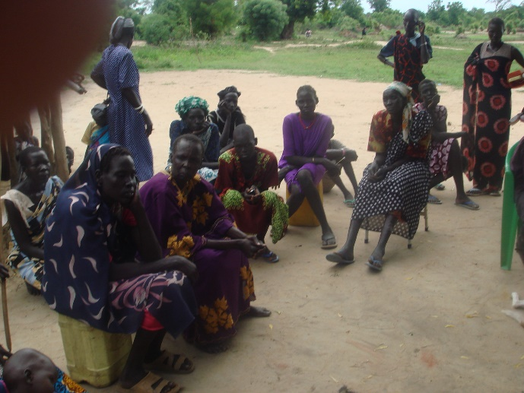

*Locally constructed pit Latrine*

*Community sensitization on water and sanitation*

*Excavation of pit Latrine*

**Adeng Rual has Completed her pit latrine in Timbar Village of Rumbek East**